Instructions for making equipment reservation

1. Go to calendar in your KGI outlook account
2. Click “Add” and open the “Global Address List”, search for 535 and you’ll see the equipment calendar. Choose the equipment you use to add to your calendar.

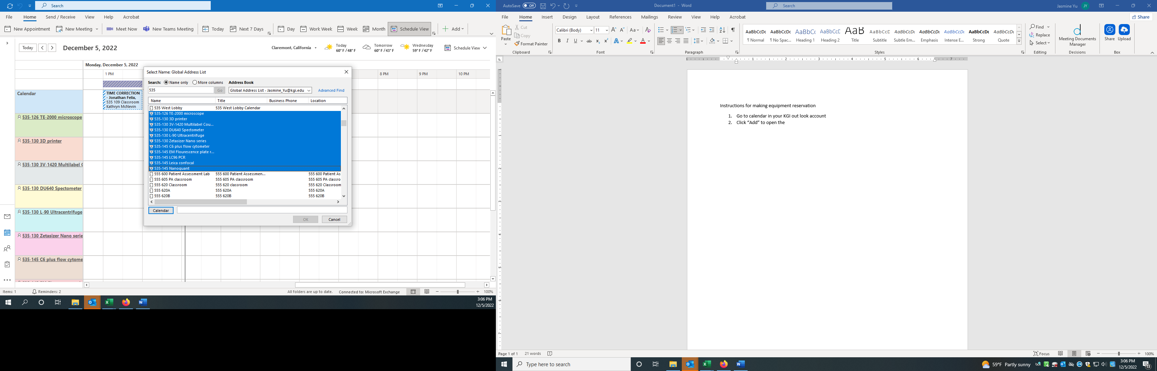

1. Now you can see all the equipment calendar under “Rooms”. Click on the equipment you wish to reserve and click on the date to choose the time you want to reserve. Please put your name and your PI’s name under “Title”.

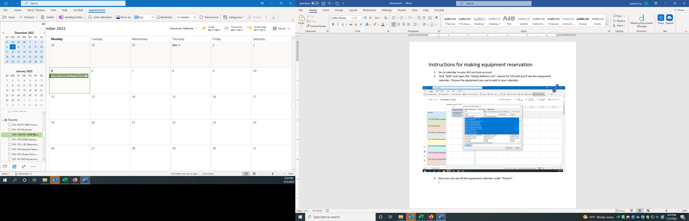

1. Please make reservation 24 hours before using shared equipment to avoid confliction. If the instrument is free, you can still reserve and use it the same day.
2. If your plan changes, please remember to cancel your reservation as early as possible so that other people can reserve and use it.
3. Please do not reserve the instrument for more than continuous 4 hours so that other labs can still use it.
4. If using the shared equipment without making reservations, your experiment can be terminated by other labs who reserved the time slots of this instrument.
5. Please always remember to sign up on the instrument usage sign-in sheets even though you have made reservations.